Educational Organisation Using ServiceNow

Team ID:-LTVIP2026TMIDS24994
Team Members:-
Vinukollu Pavan Teja
Vampolu Ravi Kumar
Vasireddy Hema Naga Sri
Tummalapalli Venkata Sai

1. INTRODUCTION

1.1 Project Overview

Educational institutions handle a large number of academic and administrative activities every day. These activities include managing student requests, handling faculty responsibilities, maintaining records, and providing various academic services. In many institutions, these processes are still managed manually or using multiple disconnected systems. This often leads to delays, communication gaps, and inefficiencies in managing institutional operations.

The Educational Organisation Using ServiceNow project is designed to solve these problems by implementing an automated system using the ServiceNow platform. ServiceNow is a powerful cloud-based platform that helps organizations automate workflows, manage services, and improve operational efficiency. By using this platform, educational institutions can simplify complex processes and provide better services to students and staff.

This project introduces a centralized system where students, faculty members, and administrators can interact through a unified platform. Students can submit their requests online, faculty members can manage academic activities, and administrators can monitor the entire system efficiently. The system ensures transparency, faster processing of requests, and better communication among all users.

The project also focuses on workflow automation, which means that once a request is submitted, the system automatically routes it to the appropriate department or authority. This reduces manual effort and improves the speed of service delivery. Overall, the system enhances productivity and improves the management of educational services.

1.2 Purpose
The main purpose of this project is to develop an efficient and automated system for managing educational institution services using the ServiceNow platform. The system aims to improve communication between students, faculty, and administrators while ensuring that requests are processed quickly and accurately.
Another important purpose of this project is to reduce manual work and paperwork in educational organizations. By automating workflows, the system helps institutions manage their services in a structured and organized way. The project also aims to provide better tracking of requests, improve accountability, and ensure that all tasks are completed within the required time.

2. IDEATION PHASE

2.1 Problem Statement

In many educational institutions, handling student services and administrative tasks is a challenging process. Students often need to submit requests related to certificates, course information, or academic issues. However, due to manual processing systems, these requests take a long time to be resolved. Additionally, there is often no proper tracking system to monitor the status of these requests.

Faculty members and administrators also face difficulties in managing a large number of student queries and tasks. Without a centralized system, communication becomes complicated, and important information may be lost or delayed. This results in dissatisfaction among students and increased workload for staff.

Therefore, there is a need for a system that can centralize all educational services, automate workflows, and improve communication between students and administrators. The Educational Organisation Using ServiceNow project addresses this problem by providing an efficient and automated platform for managing institutional services.

2.2 Empathy Map Canvas

Users:
Students, Faculty Members, Administrative Staff

What they think
- Students want quick responses to their requests.
- Faculty members want an organized system to manage academic tasks.
- Administrators want better control over institutional operations.

What they feel
- Students feel frustrated when their requests are delayed.
- Faculty members feel stressed due to managing multiple tasks manually.
- Administrators feel pressure to maintain efficiency in the institution.

What they say
- “My request has not been approved yet.”
- “It is difficult to manage student requests manually.”
- “We need a faster and more reliable system.”

What they do
- Submit requests manually through forms or emails.
- Follow up repeatedly for approvals.
- Maintain records using spreadsheets or documents.

2.3 Brainstorming
During the brainstorming phase, several ideas were discussed to solve the identified problems. The main goal was to create a system that could simplify educational processes and improve efficiency.
Some of the ideas discussed include:
- Creating a centralized service portal for students and faculty.
- Implementing workflow automation to handle requests automatically.
- Providing real-time notifications to users.
- Using ServiceNow to manage educational services effectively.
- Designing a user-friendly interface for easy access to services.
After evaluating these ideas, the team decided to implement the system using the ServiceNow platform because of its strong workflow automation capabilities and service management features.

3. REQUIREMENT ANALYSIS

3.1 Customer Journey Map

The customer journey describes how users interact with the system from start to finish. The process begins when a user logs into the system and continues until the request is resolved.

The steps involved in the journey include:
- The user logs into the ServiceNow portal.
- The student selects a service and submits a request.
- The system verifies the request details.
- The request is forwarded to the appropriate department.
- The concerned authority reviews the request.
- The request is approved or rejected.
- The system notifies the student about the status of the request.

This journey ensures a smooth and structured process for handling requests within the institution.

3.2 Solution Requirements

Functional Requirements

The functional requirements define the features that the system must provide:
- User registration and login system.
- Student service request submission.
- Workflow-based approval process.
- Notification system for updates.
- Request tracking system.
- Administrative dashboard.

Non-Functional Requirements

The non-functional requirements define the quality attributes of the system:
- Security and data protection.
- High system performance.
- Scalability for future expansion.
- Reliability and availability.
- User-friendly interface.

3.3 Data Flow Diagram (DFD)

The Data Flow Diagram explains how data moves through the system.

Student → System: Submit request
System → Department: Assign request
Department → System: Update status
System → Student: Notify result
Administrator → System: Monitor activities

This process ensures efficient handling of data and requests within the system.

3.4 Technology Stack
The system is developed using the following technologies:
Platform: ServiceNow
Modules Used:
- Service Catalog
- Incident Management
- Workflow Automation
- User Management
Tools Used:
- ServiceNow Studio
- Flow Designer
- Service Portal

4. PROJECT DESIGN

4.1 Problem–Solution Fit

The proposed system directly addresses the problems faced by educational institutions. By implementing a centralized platform, the system eliminates manual processes and improves communication between students and administrators.

The system ensures that requests are handled efficiently, and users can track their status at any time. This improves transparency and accountability within the organization.

4.2 Proposed Solution

The solution involves creating a ServiceNow-based portal where users can access various educational services. Students can submit their requests through the portal, and the system automatically routes these requests to the appropriate departments.

Faculty members and administrators can review and approve requests through the system dashboard. Automated notifications ensure that users are informed about the progress of their requests.

4.3 Solution Architecture
The architecture of the system includes the following components:
User Interface – ServiceNow Portal for students and staff.
Application Layer – Workflow automation and request management.
Database Layer – Stores user information and request data.
Notification System – Sends alerts and updates to users.

5. PROJECT PLANNING & SCHEDULING

5.1 Project Planning
The project was planned and executed in several phases to ensure proper development and implementation.

The phases include:
- Requirement analysis and research.
- Designing the system architecture.
- Development of the ServiceNow portal.
- Configuration of workflows and services.
- Testing and debugging.
- Final implementation.
Each phase was carefully planned to ensure the successful completion of the project.

6. FUNCTIONAL AND PERFORMANCE TESTING

6.1 Performance Testing
Performance testing was conducted to evaluate the efficiency and reliability of the system. The testing ensured that the system could handle multiple users simultaneously without any issues.
The following aspects were tested:
- System response time during multiple requests.
- Workflow execution speed.
- Accuracy of request processing.
- Notification delivery.
- System reliability.
The results showed that the system performs efficiently and meets the required standards.

7. RESULTS

7.1 Output Screenshots

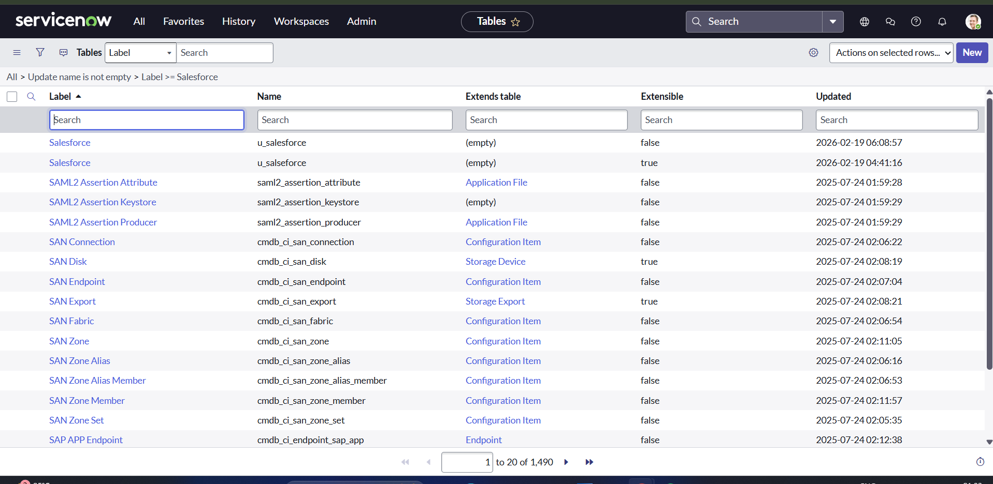

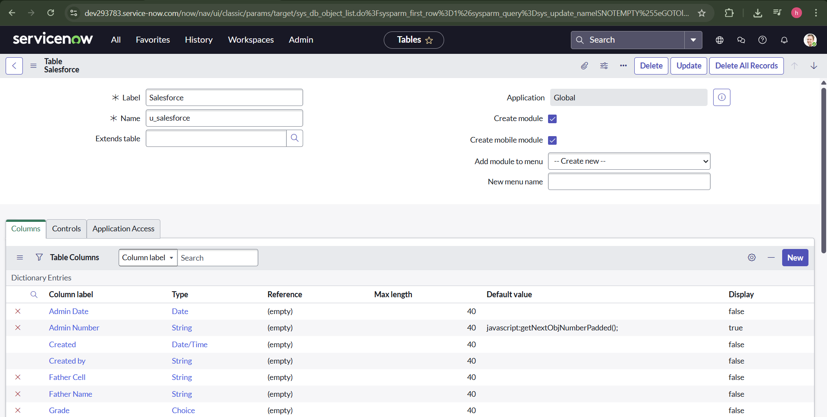

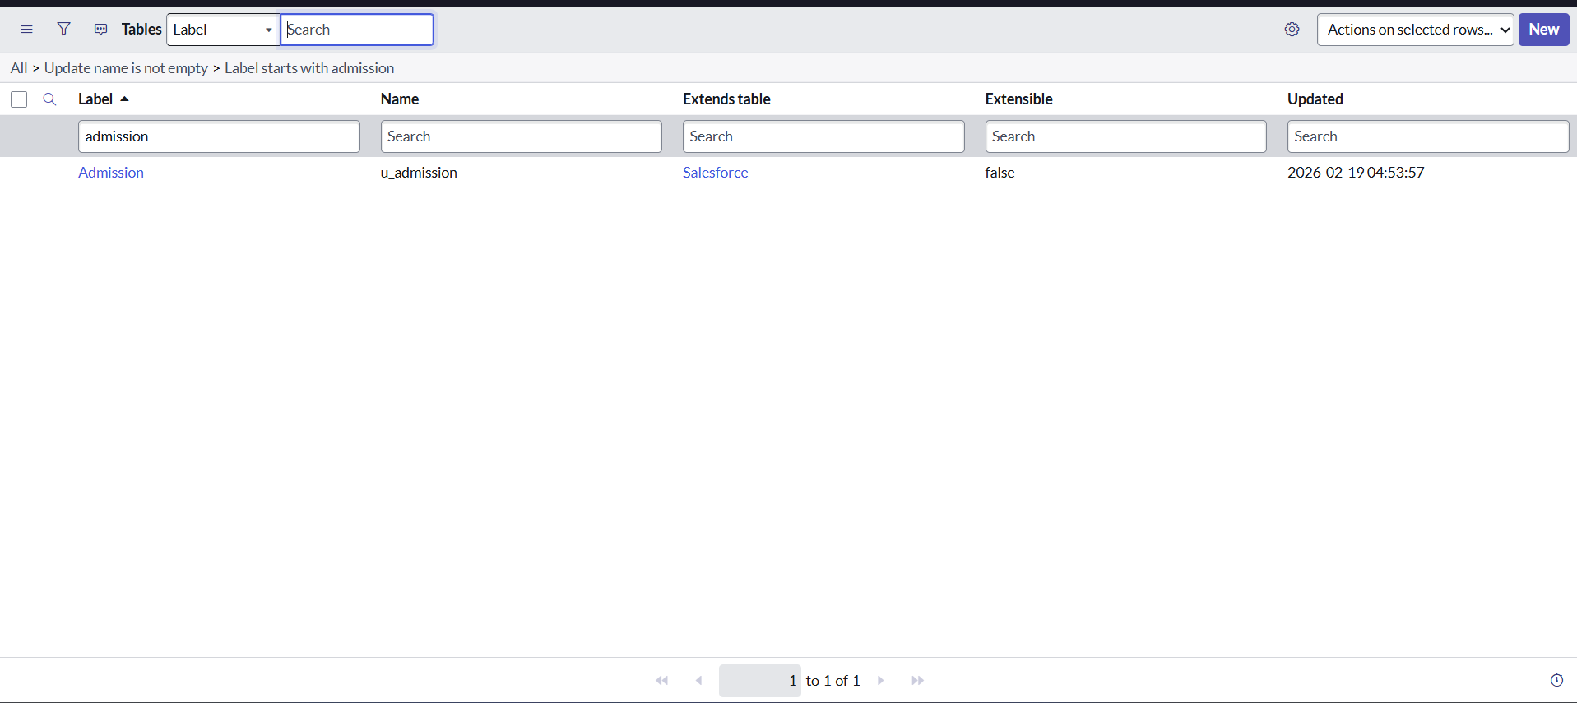

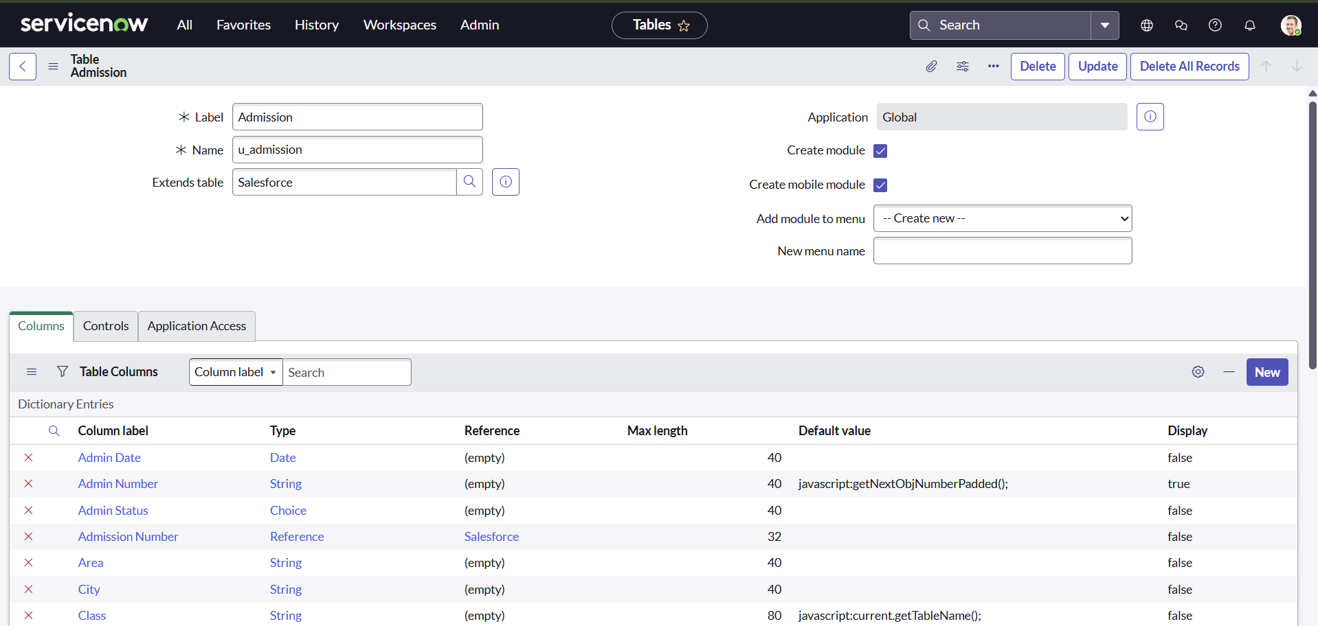
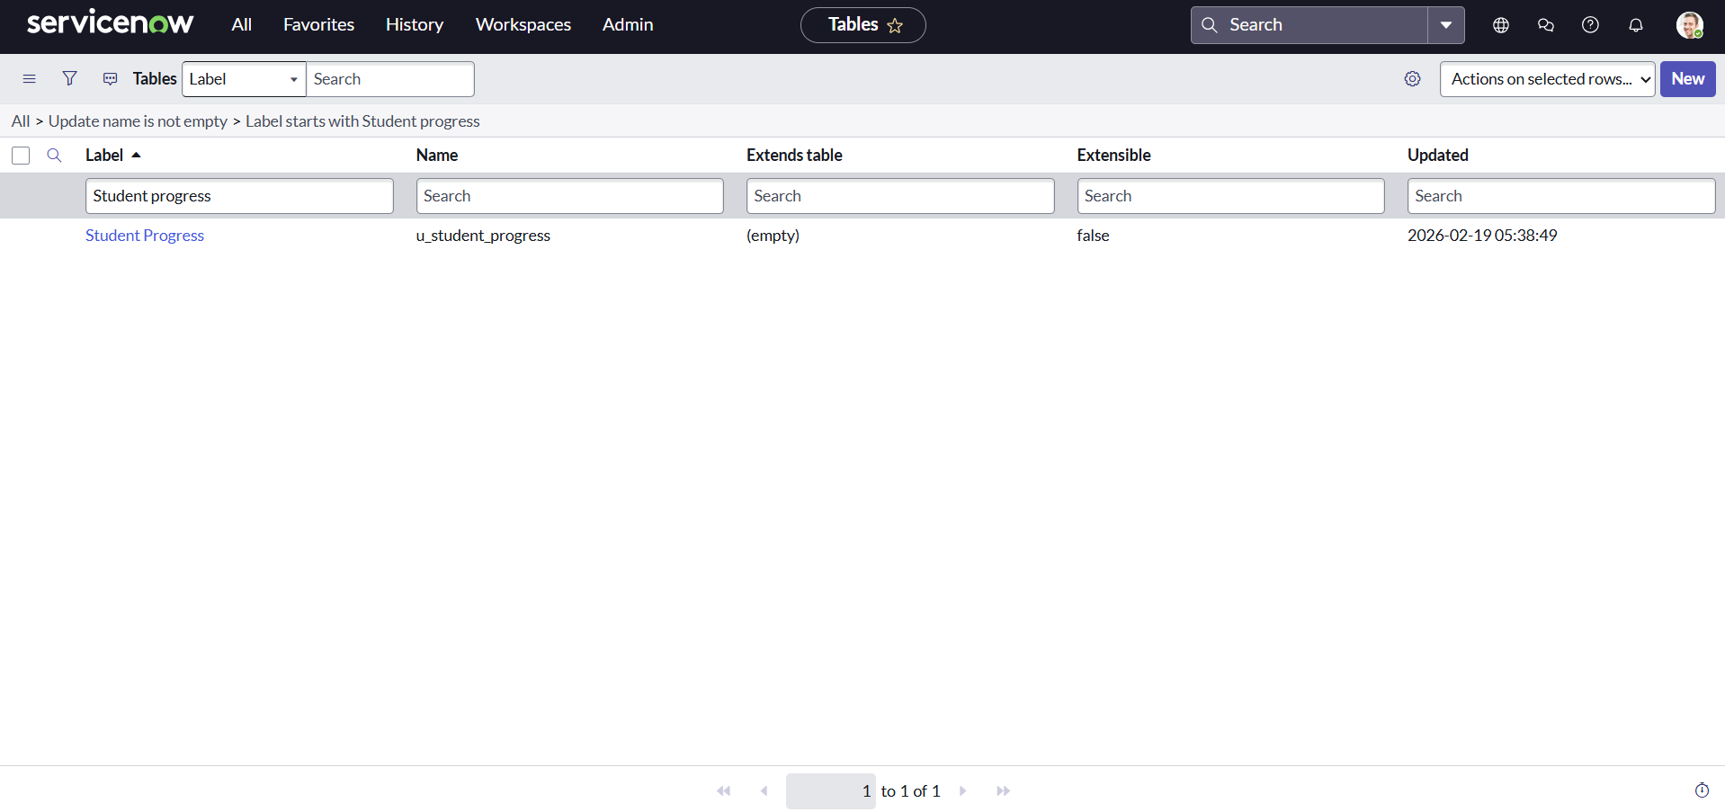
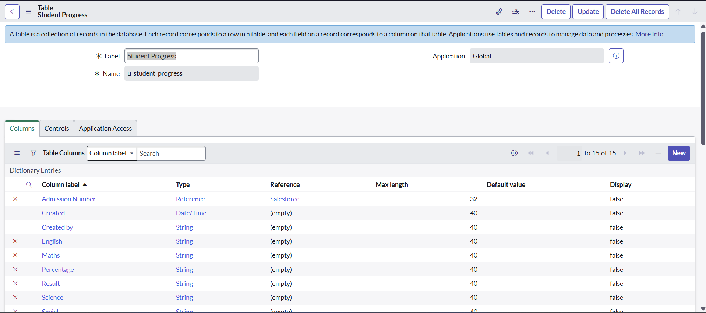
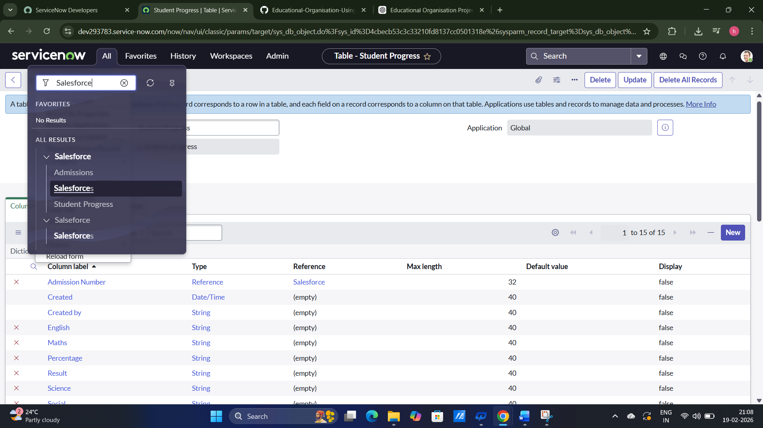

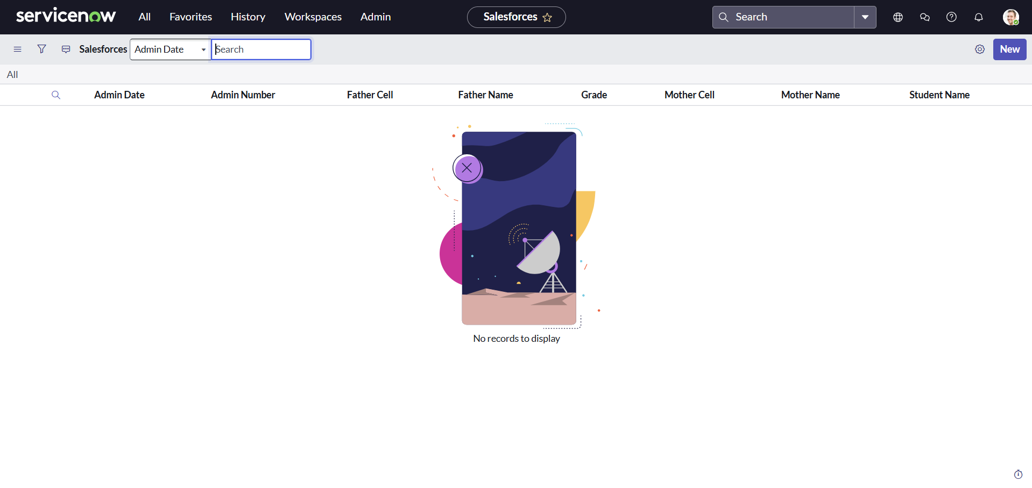
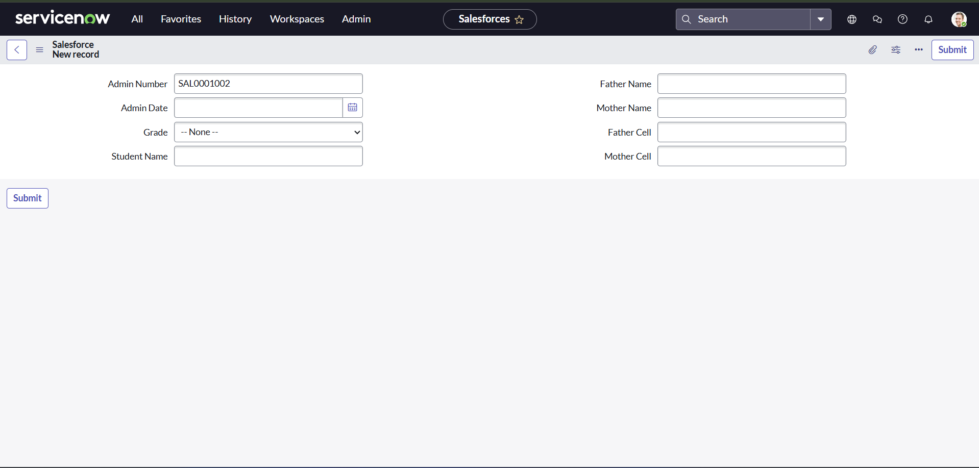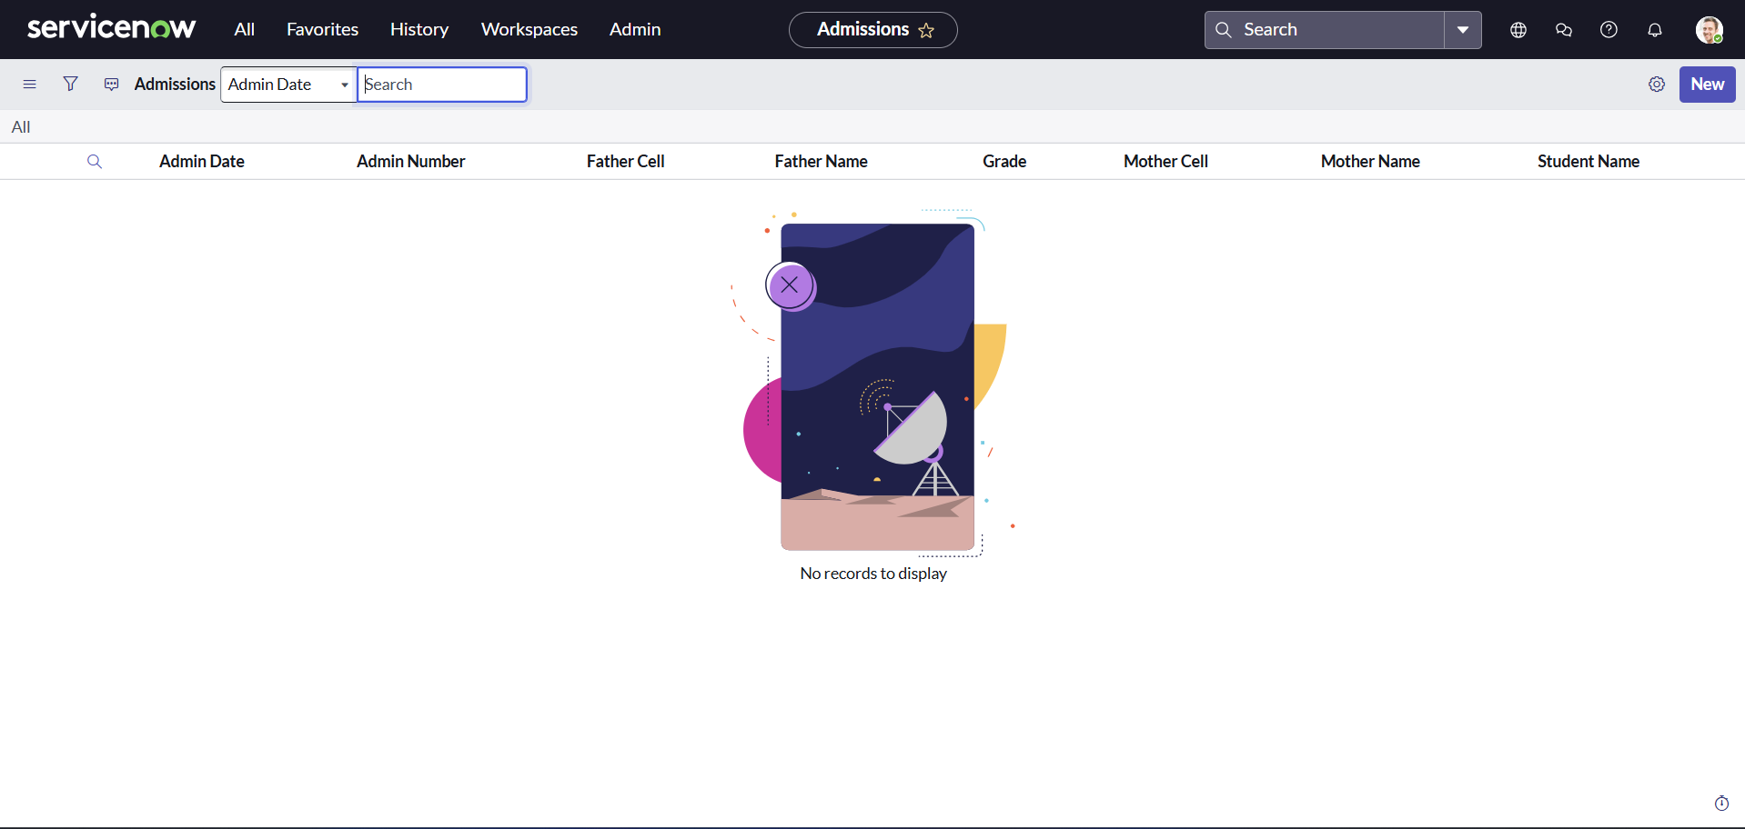

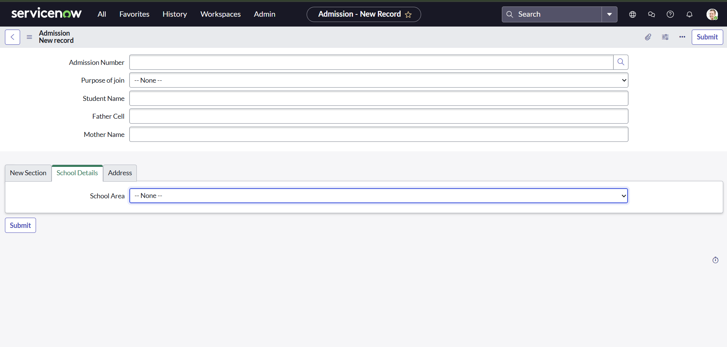
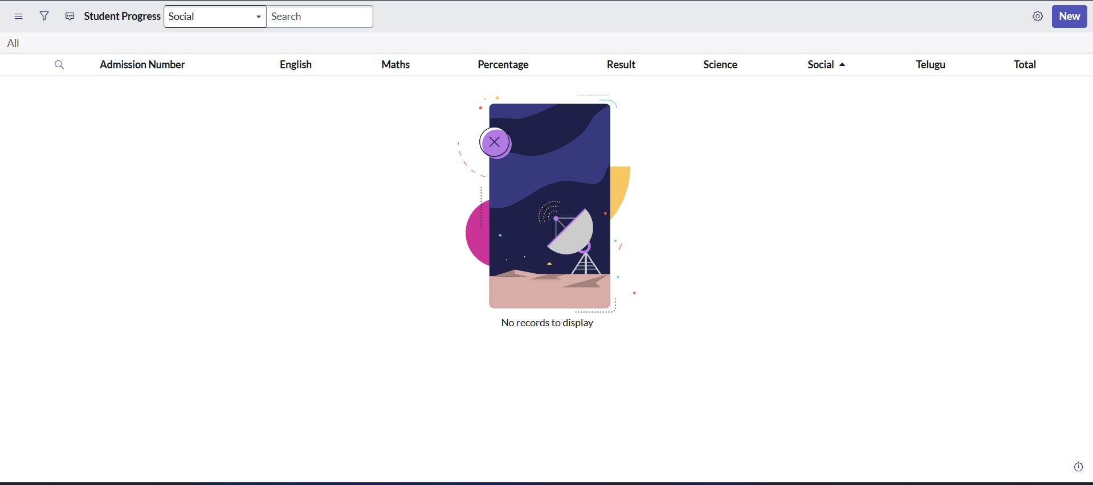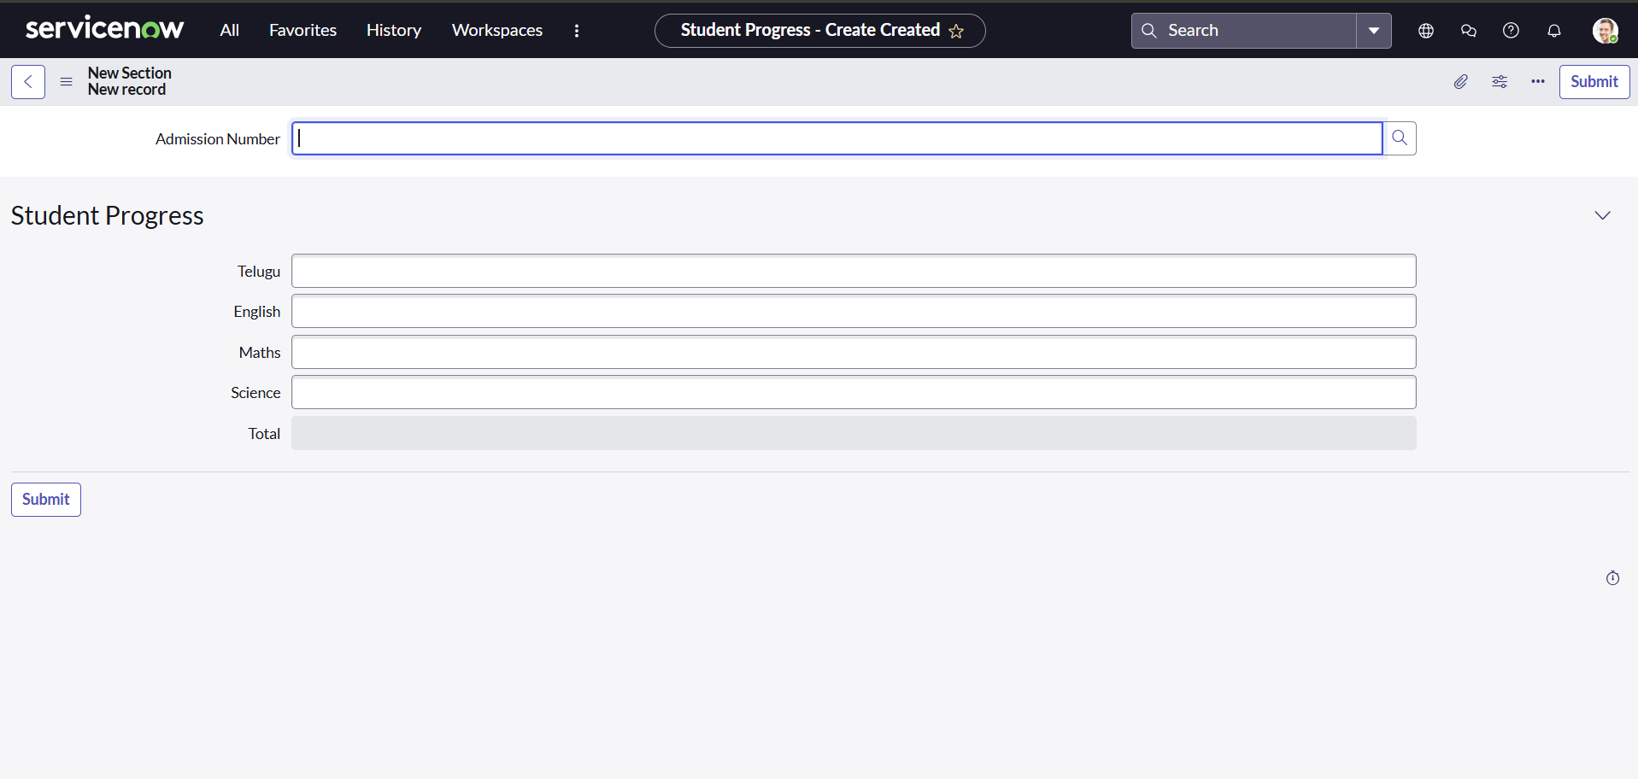

8. ADVANTAGES & DISADVANTAGES

Advantages
- Centralized system for managing educational services.
- Faster processing of student requests.
- Improved communication.
- Reduced manual work.
- Better tracking and transparency.
- Automated workflows increase efficiency.

Disadvantages
- Initial setup requires time and configuration.
- Requires knowledge of ServiceNow.
- Internet connectivity is necessary.

9. CONCLUSION
The Educational Organisation Using ServiceNow project successfully demonstrates how modern technology can improve the efficiency of educational institutions. By implementing a centralized platform, the system simplifies the management of student services and administrative tasks.
The project highlights the importance of automation in improving communication, reducing manual workload, and enhancing overall productivity. With the help of ServiceNow, institutions can provide better services and ensure a more organized workflow..

10. FUTURE SCOPE
The system can be further improved by adding advanced features such as:
- Mobile application integration.
- Artificial intelligence for request prioritization.
- Advanced analytics and reporting.
- Integration with existing student management systems.
- Automated chatbot support for students.

11. APPENDIX

GitHub & Project Demo Link
- GitHub:- https://github.com/VasieddyHemaNagaSri/Educational-Organisation-Using-ServiceNow
- Demo Link : https://drive.google.com/file/d/1I6Md0UXUVzxHWmymZkzoIVO9fSXglBGS/view?usp=drive_link

